Design document

Phase2section1

EECE 4830

The sender program clientco.py reads the file in small pieces and adds a small label to each piece with its type, a number 0 or 1, its size, and a checksum. The checksum helps catch any bit flips. After sending a piece, the sender waits for an ACK from the receiver with the same number. If the receiver says OK and the number matches, the sender changes the number from 0 to 1 or from 1 to 0 and sends the next piece. If the piece or the ACK is broken or missing, the sender sends the same piece again. The receiver also helps by sending the last good ACK again when it sees a duplicate. This simple loop of send, wait, check, and retry keeps the transfer correct even when some bits flip. It makes sure the file you send is the same as the file you get, even though we use UDP, which does not guarantee safe delivery. Think of it like two people reading a list over the phone and saying got it after each item so nothing is missed.

How to run it in easy steps: put a test file at least 500 KB in the same folder as the scripts. For example, use a file named udpfile.jpg. Open two terminals. Start the receiver first with: python serverco.py. This is Option 1 with no errors. In the other terminal start the sender with: python clientco.py. You should see a file named udpfile_received.jpg appear; its size should match the original. For Option 2 with ACK errors keep the server normal and run the sender with a flip chance, for example: python clientco.py --ackp 0.05 for five percent. For Option 3 with data errors start the server with a flip chance, for example: python serverco.py --datap 0.05, and run the sender normally. Restart the server each time you change datap. Each run prints the total time in seconds. Write those times for 0 percent, 5 percent, 10 percent, and so on up to 60 percent into measurements.csv, then make the plot with: python plotchart.py. It saves a picture named results.png. On Windows you can use py instead of python. If the sender waits for a long time, check that the server is running and that both sides use the same port, which is 12007.

Option 1 No bit errors 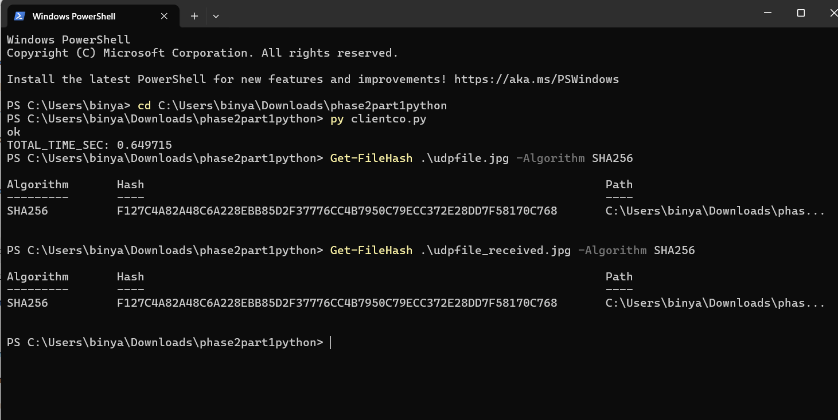

Option 2

Option 3

